Requirements: You need to have Python and MongoDB installed in your computer

**Twitter Crawler using Tweepy library**

Open Command Prompt and type ‘pip install tweepy’, followed by ‘pip install pymongo’.

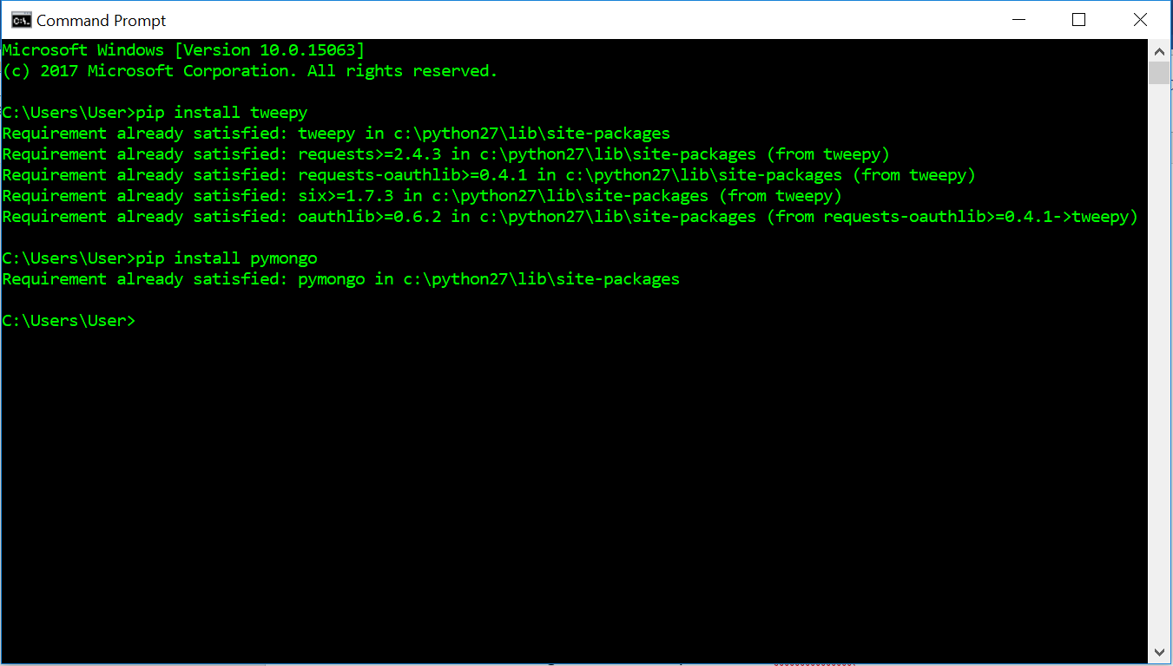

Create an application management account under Twitter at <https://apps.twitter.com> .

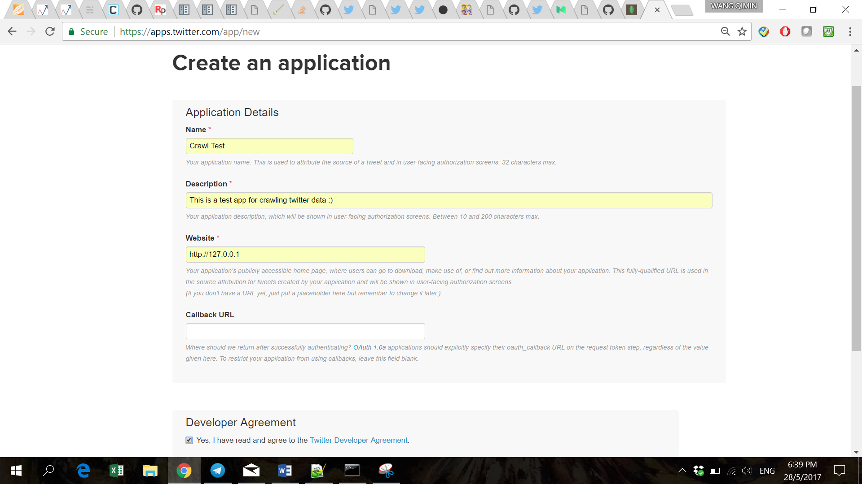

Create ‘credentials_twitter.py’ and enter the CONSUMER_KEY, CONSUMER_SECRET, ACCESS_TOKEN, ACCESS_SECRET given in your twitter application account, save it.

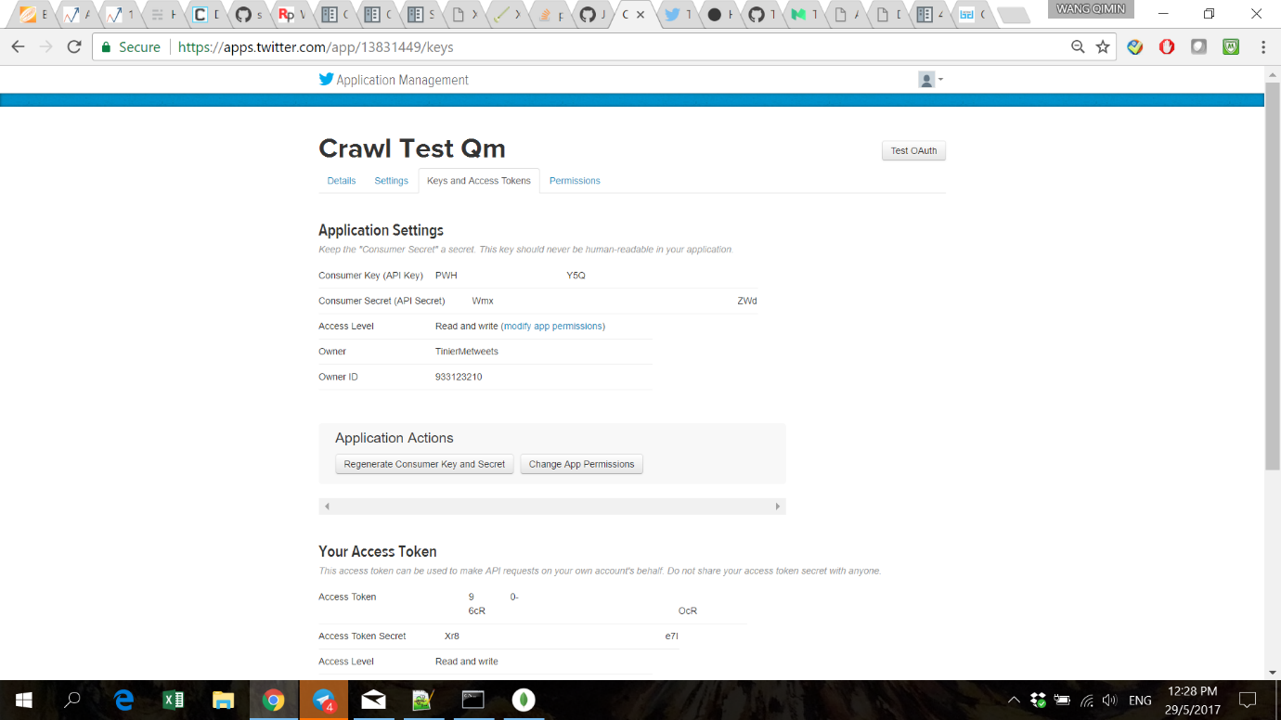

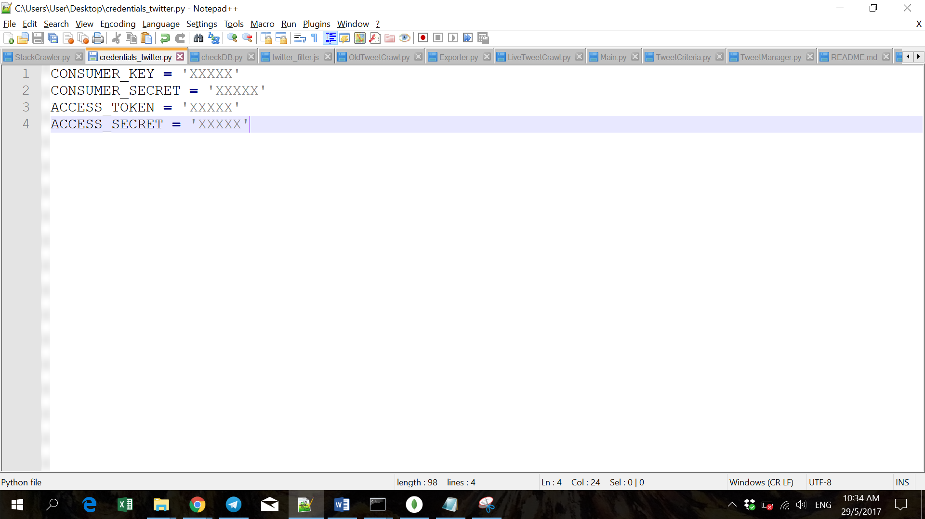

Create ‘keywords.txt’ and enter the keyword(s) to be queried from Twitter, save it.

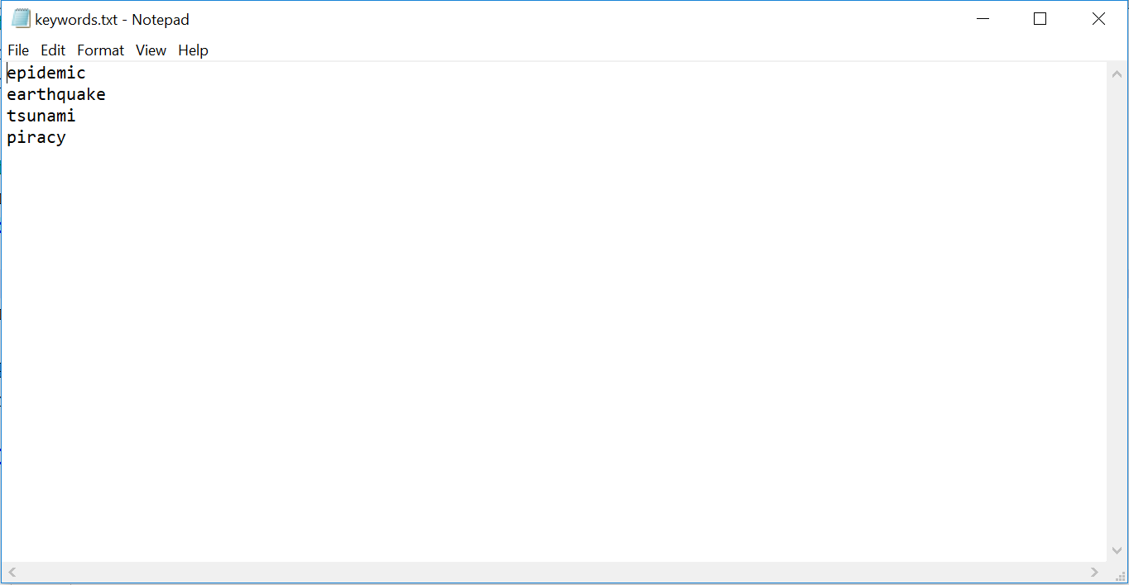

1. Live Streaming of tweets

Open LiveTweetCrawl.py, edit KEYWORDS_PATH to the path where you stored ‘keywords.txt’.

Edit variable timeLimit as needed, in seconds.

Edit MongoDB properties as required.

Open Command Prompt and change directory to the MongoDB bin folder, type ‘mongod’.

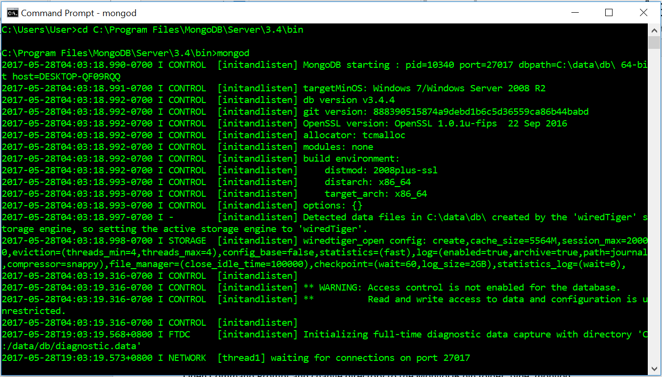

Open another Command Prompt and change directory to location of ‘LiveTweetCrawl.py’, type ‘python LiveTweetCrawl.py’.

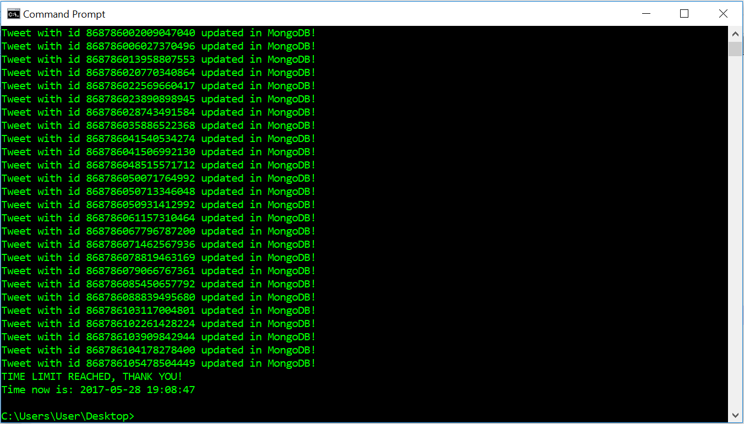

1. Searching for tweets up to 1 week ago

Open OldTweetCrawl.py, edit KEYWORDS_PATH to the path where you stored ‘keywords.txt’.

Edit variable maxTweets depending on how many tweets you wish to crawl.

If results from a specific tweet ID onwards are required, set sinceId to that ID. Else, default to no lower limit, go as far back as API allows.

If results only below a specific tweet ID are required, set maxId to that ID. Else, default to no upper limit, start from the most recent tweet matching the search query.

Edit MongoDB properties as required.

Open Command Prompt and change directory to the MongoDB bin folder, type ‘mongod’.



Open another Command Prompt and change directory to location of ‘OldTweetCrawl.py’, type ‘python OldTweetCrawl.py’.

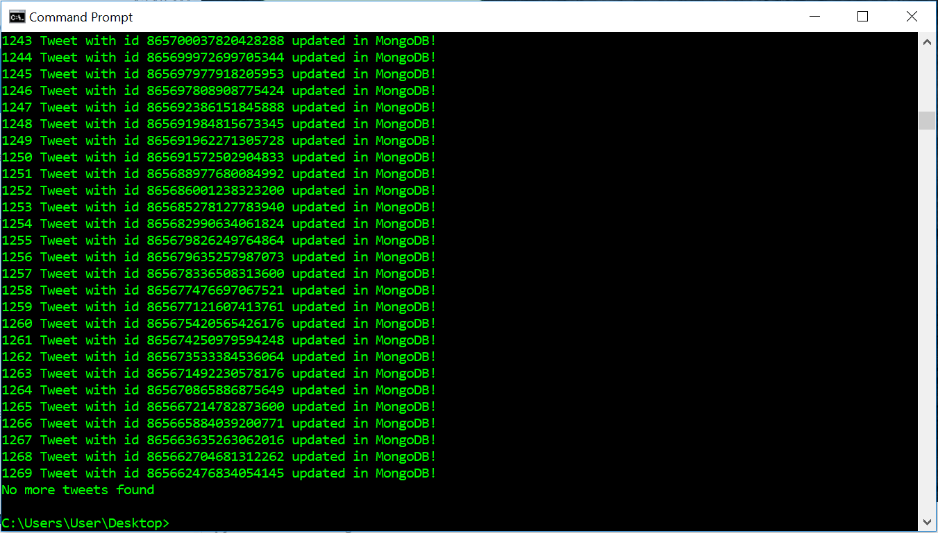

**Twitter Crawler using Selenium library & Chrome webdriver**